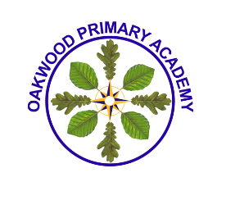
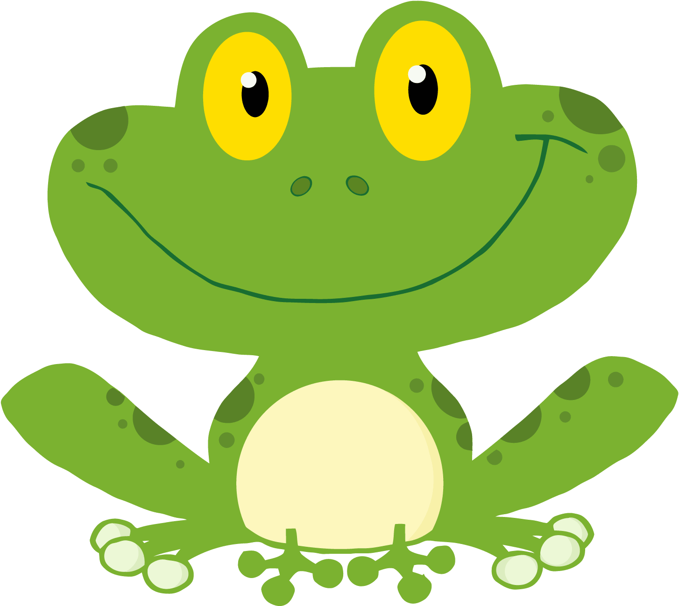
Oakwood Primary Academy
Learning Journey for this term and how you can support your child Foundation Frogs and Dragonflies

In our Prime Areas of Learning we will be:

Personal, Social and Emotional Development | - Thinking about transitions to Year 1 in September.  - Talking about plants and animals and how we care for them (e.g. through our minibeast project, growing sunflowers, runner beans, looking after our tadpoles and butterflies).  - Thinking about our own and different cultures and beliefs (e.g. through our Around the World topic).
Communication and Language | - Listening to, reciting and acting out a wide range of stories in Talk for Writing. Making story maps to help our recall.  - Answering ‘how’ and ‘why’ questions about our experiences and in response to stories and events.  - Using past, present and future tenses correctly.
Physical Development | - Sports Day skills: running, hopping, skipping. Working as part of a team.  - Continue to handle familiar and new tools safely and with basic control (e.g. using gardening equipment in our outside space).  - Holding pencils correctly.  - Understanding the importance of exercise and a healthy diet.

In our Specific Areas of Learning we will be:

Literacy | - Learning our final phase 3 and 4 sounds and high frequency words.  - Continue blending and segmenting our sounds to help us read and write simple words, captions and sentences.  - Forming our letters neatly and correctly. Writing on the line and understanding which letters are ascenders and descenders.  - Beginning to use basic punctuation.  - Continue our Ten a Term Reading programme, where we focus on learning a specific story book each week.
Mathematics | - Continue to recognise numbers 1-20 and beyond. Practise correct number formation.  - Developing strategies for solving simple addition and subtraction problems (e.g. fingers, number lines, counting on, counting back).  - Begin to write number sentences using the correct notation (- + and =).  - Comparative measurement: height, capacity, weight, length (e.g. of ourselves, sunflowers and runner beans).  - Identifying 2D and 3D shapes and talk about their properties.
Understanding the World | - Learning about seasonal changes from Spring to Summer.  - Find out about past events in own lives and the lives of others.  - Learn about growth and change (e.g. through observations of our tadpoles).  - Exploring different countries and cultures through our Around the World topic e.g. India.
Expressive Arts and Design | - Building up a repertoire of songs and dances.  - Participating in daily Wake and Shake.  - Exploring musical instruments.  - Exploring a variety of materials, experimenting with colour, design. texture, shape and form.

Things to Remember:
- Please bring book bags in daily for letters, library books, reading diaries and home learning books etc. School book bags are preferable to rucksacks, as they are more easily stored in the class book bag box.
- Reading books are changed daily. Please ensure you have updated your child’s reading diary if you would like your child’s book changed. Library book change – Friday.
- As part of our healthy school’s policy, children are encouraged to drink water throughout the day. Please ensure that your child has a named, clear water bottle in school, especially during the summer months. Juice/squash are not permitted in water bottles. Milk and water are provided at snack time.
- Please ensure that all clothing including footwear, coats and PE kits are clearly named.
- Reception children are not permitted to wear earrings.
- P.E. kit – we will be doing PE on Fridays, please ensure your child’s kit is in school every day. Your child will need trainers or plimsolls this term for Sports Day practise.
- Busy Books are sent home on a Friday with a challenge activity for you to complete with your child. Please return it by the following Wednesday, so that the next activity can be added.
- The children earn treasure stamps in school for good behaviour, work, effort and following the school rules. When they have collected 20 treasure stamps, they earn a small reward from the class treasure chest to bring home. Teachers keep a record of treasure stamps collected across the year, and the children can exchange these for school ‘coins’ to spend in the school treasure shop.

Thank you for your support.
If you have any questions or queries, please contact a
member of the Foundation Team:
Mrs. Tracy O’Carroll – EYFS Team Leader
Mrs Palfrey – Class Teacher
Mrs Claire Harris – Higher Level Teaching Assistant
Miss. Kirsty Daw – Early Years Teaching Assistant
Mrs. Julie Jackson – Early Years Teaching Assistant

